ELEC-2110

Electric Circuit Analysis

FROM: Jacob Howard

TO: Markus Kreitzer

DATE: January 29, 2020

LAB SECTION: 002

***Electrical Measurements: More Practice with***

***DC Measurements***

# Introduction

The Objective of this lab was to practice more with the Elvis board and learn how to use its software. The Elvis board computer software comes with a variety of tools that are very helpful with circuits constructed on the board. The “Variable Power Supplies” app was mostly used in this lab to set a variable voltage of 7 volts.

# Exercise 1

1. In exercise 1, we were asked to use the NI ELVIS board’s 5 V [fixed] power supply and variable power supply (set at 7 V). We then set up the variable power supply as shown in Figure 1 (shown below) and verify the voltage with a DMM as shown in Figure 2 below. We were then also asked to verify the voltage of the 5 V supply and record the measured values of the power supplies in your lab report [1]. Measured value of variable voltage is below in Table 1.

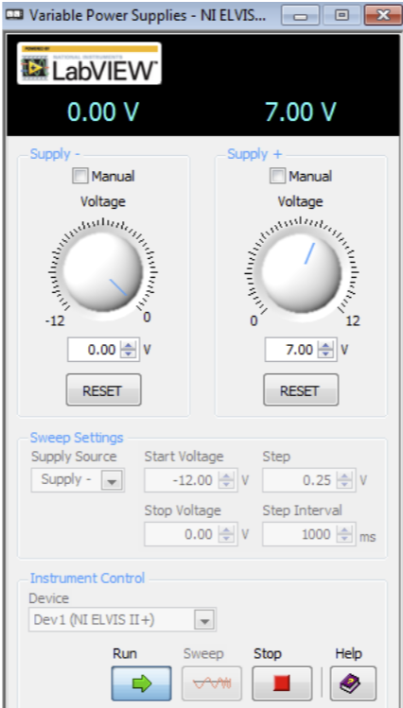

*Figure 1*

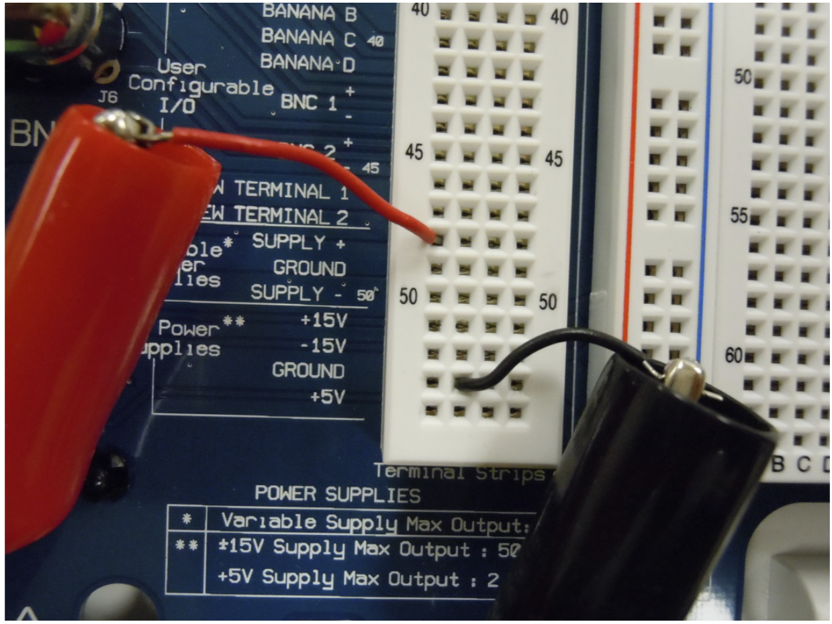

*Figure 2*

|  |  |
| --- | --- |
| **Variable Voltage** | 6.9967 V |

*Table 1*

# Exercise 2

All resistors used in the exercises will be theoretically 330 Ω. We were asked to create a table of the resistors measured values (R1 through R7) [1]. The measured resistance is shown below in Table 2.

|  |  |
| --- | --- |
| **Theoretical Resistance 470 Ohm** | **Actual Resistance** |
| **R1** | 464.70 |
| **R2** | 466.14 |
| **R3** | 470.92 |
| **R4** | 471.39 |
| **R5** | 466.72 |
| **R6** | 466.53 |
| **R7** | 464.57 |

*Table 2*

# Exercise 3

In exercise 3, we were asked to Breadboard the circuit in Figure 3 below. We were the asked to [1]:

* Measure VA, VB, VC, VD, VAC, and VBC. We also we to verify Kirchhoff’s Voltage Law using VA, VC, and VAC.
* Verify Kirchhoff’s Voltage law using VB, VD, and VBD.
  + VAC = VA – VC
  + VBD = VB - VD
* Using the measurement for IDC, calculate the value for IAB (do not use your voltage measurements from this exercise in this calculation).

Measurements are below in Table 3 and equations and work used are in Equations 1.

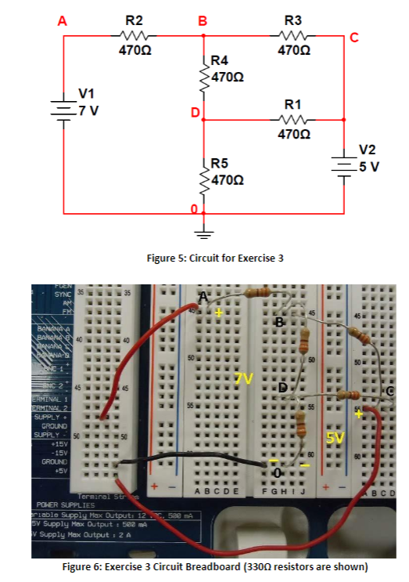

*Figure 3*

|  |  |  |
| --- | --- | --- |
| **Variables** | **Measured Values** | **Calculated Value** |
| **VA** | 6.9967 V | ------- |
| **VB** | 5.1078 V | ------- |
| **VC** | 4.9556 V | ------- |
| **VD** | 3.3502 V | ------- |
| **VAC** | 2.0417 V | 2.0411 V |
| **VBD** | 1.7553 V | 1.7576 V |
| **IDC** | -4.41 mA | ------- |
| **IAB** | ------- | 4.052 mA |

*Table 3*

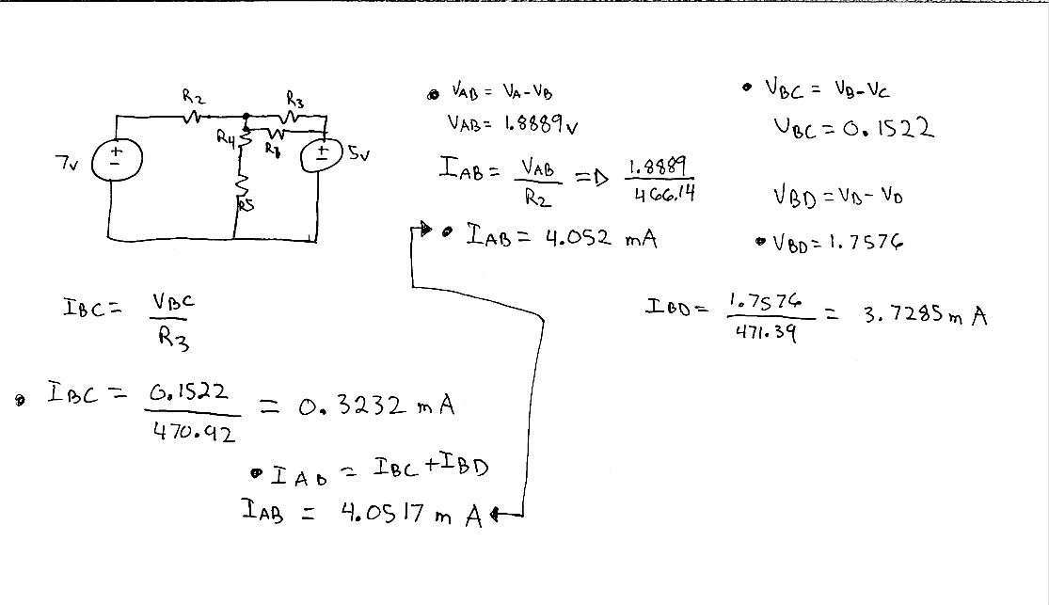

*Equations 2*

# Exercise 4

In exercise 4, we were asked to breadboard the circuit in Figure 4 below. We were then asked to [1]:

* Measure VA, VB, and VC. Verify these node voltages using nodal analysis.
* Measure IBA, IB0, and IBC. Verify using Kirchhoff’s Current Law at node B.
* Calculate IBA, IB0, and IBC using your measured node voltages and resistor values (Ohm’s Law).

All Values are listed in Table 4 below and equations used are in Equations 2.

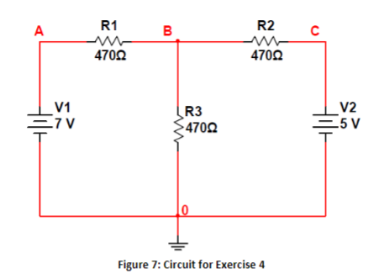

*Figure 4*

|  |  |
| --- | --- |
| **Variables** | **Measured Values** |
| **Va** | 6.9950v |
| **Vb** | 3.9985 |
| **Vc** | 4.9547 |
| **IBA** | -6.49mA |
| **IB0** | 8.46 mA |
| **IBC** | -2.09 mA |

*Table 4*

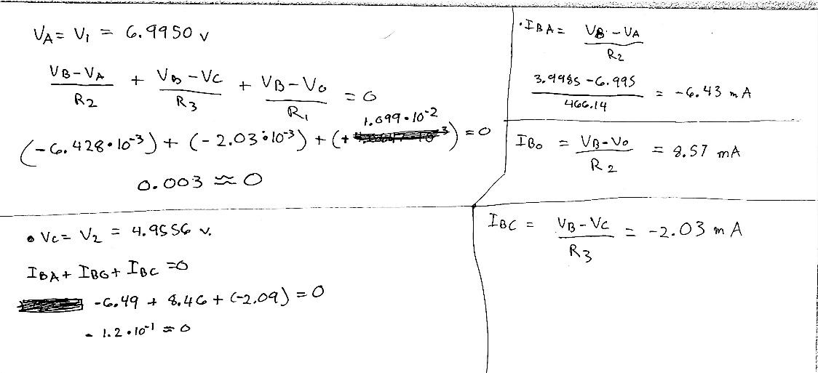

*Equations 2*

# Exercise 5

In exercise 5, we were asked to Breadboard the circuit in Figure 5 shown below. Using the circuit constructed on the Elvis Board, we were asked to [1]:

* Measure VAC, VAB, VAD, VB, VC, VCE, VD, VDE, and VE.
* Measure IAC, IAB, IAD, IC0, ICE, ID0, IDE, and IE0.
* Calculate the power absorbed by every element in the circuit.
* Verify that the sum of power absorbed by all circuit elements equals 0 W.

Data is shown below in Table 5 and formulae and equations used are in Equations 3.

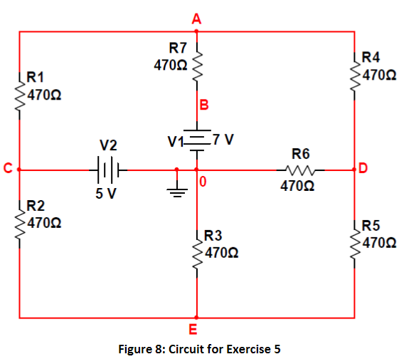

*Figure 5*

|  |  |
| --- | --- |
| **Voltage** | **Values (in Volts)** |
| **VAC** | -0.15341 |
| **VAB** | -2.1979 V |
| **VAD** | 2.3851 V |
| **VB** | 6.9949 V |
| **VC** | 4.9501 V |
| **VCE** | 2.4887 V |
| **VD** | 2.4120 V |
| **VDE** | -50.085 mV |
| **VE** | 2.4623 V |

*Table 5*

|  |  |
| --- | --- |
| **Current** | **Value** |
| **IAC** | -0.326 mA |
| **IAB** | -4.676 mA |
| **IAD** | 5.074 mA |
| **IC0** | -5.621 mA |
| **ICE** | 5.295 mA |
| **ID0** | 5.19 mA |
| **IDE** | -0.106 mA |
| **IE0** | 5.18 mA |

*Table 6*

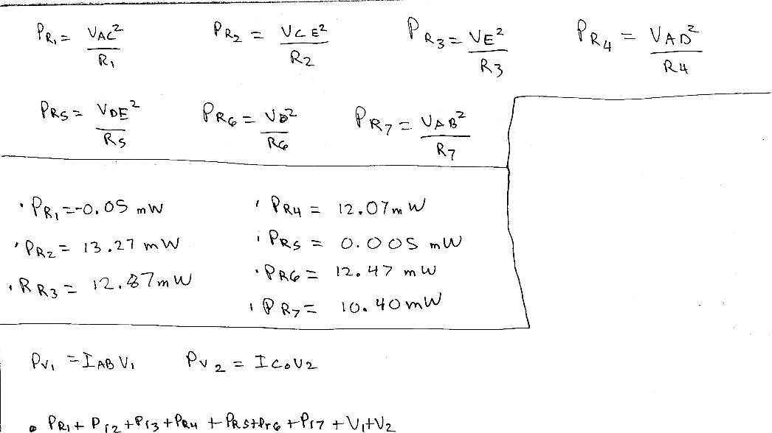

*Equations 3*

# Conclusion

This lab was used as an overview and refresher with the Elvis Board and breadboarding circuits. The circuits and calculations were slightly more advanced than previous labs and I did run into some difficulties along the way. My TA was able to help with measuring the voltage and currents correctly and some peers were able to show how to check my measurements with calculations correctly. This lab was a good refresher for breadboarding and using formulae to verify measured information.

# Bibliography

[1] Eidson, Brandon, Taylor Auston, and Elizabeth Devore. *EXPERIMENT 3 Electrical Measurements: More Practice With DC Measurements*. 2020, p. 5, Accessed 29 Jan 2020.